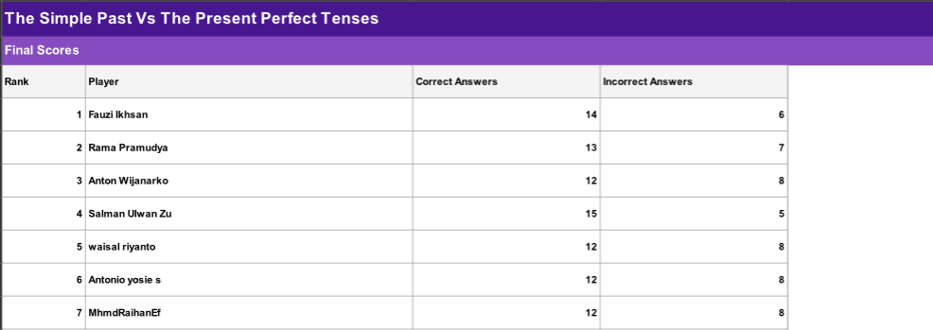

**Sorry sir my phone was error last night, but I’ve already do the test**